Pdf 1 Result
John the ripper taking too much time for cracking this file hash,
Pdf2 result:
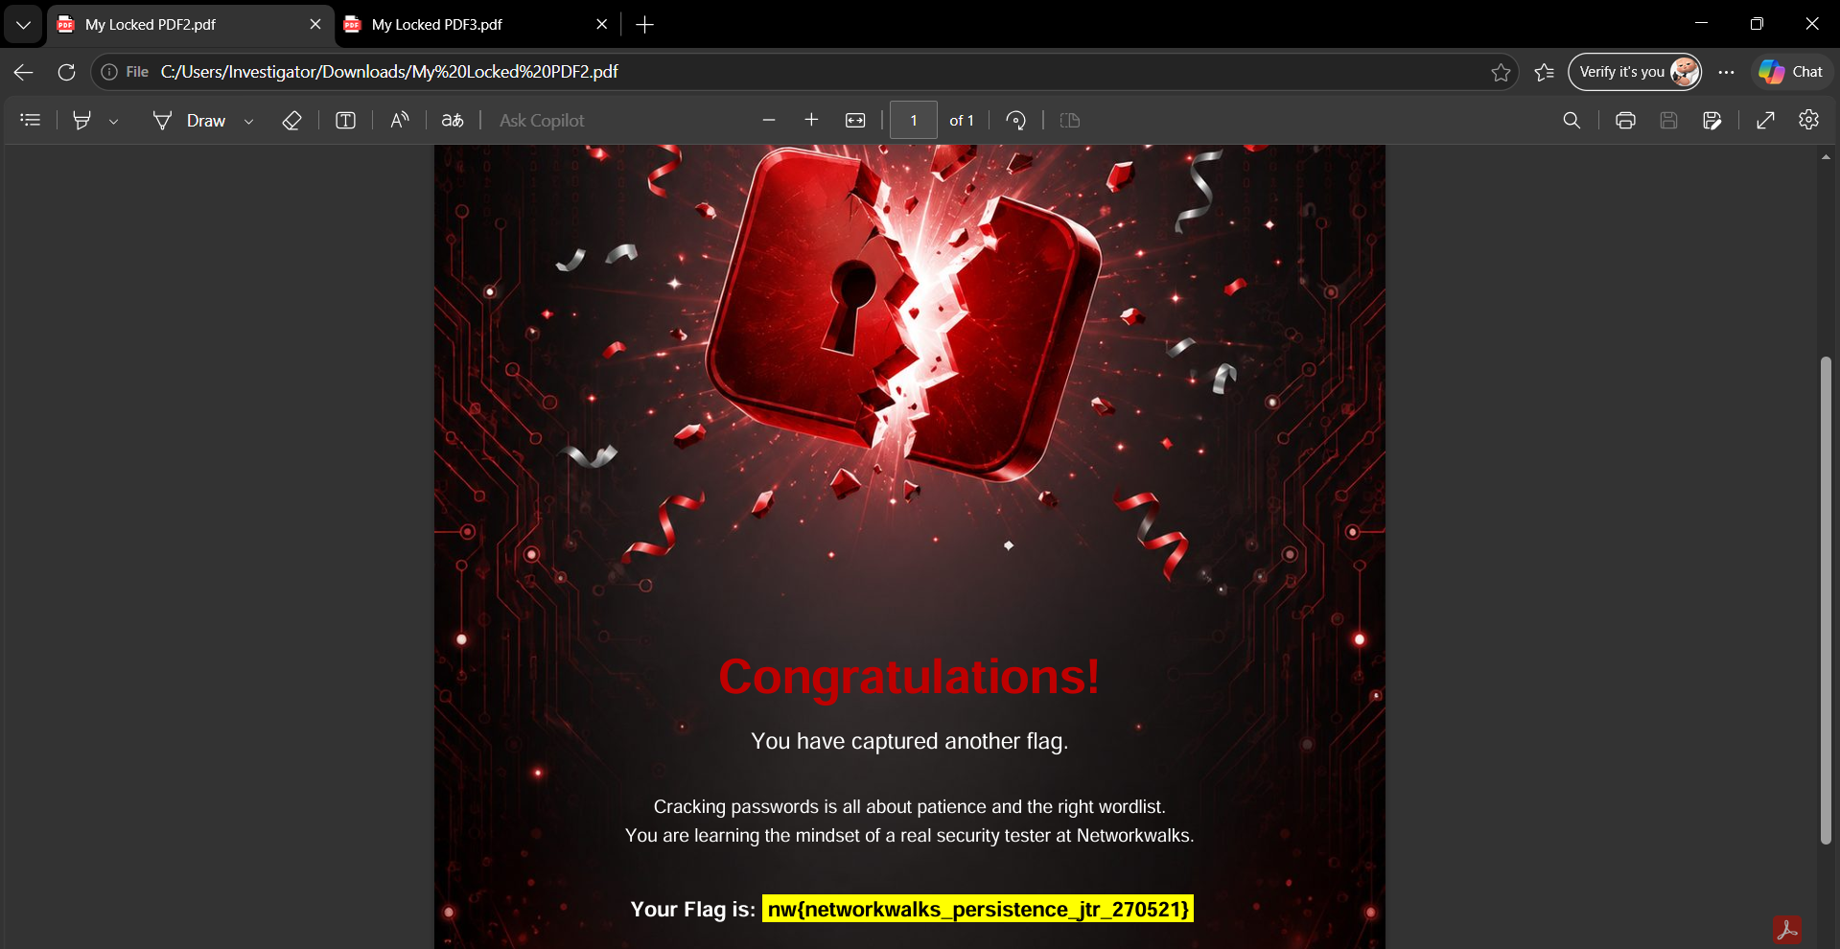
Pdf3 result:
